Retention graphs

The Steep End Drop
This is the easiest drop to fix. In fact, if you follow the method I have taught you for writing end screens, you'll see the drop-off here vanish in your next video.
To fix this you have to make the end of your video almost a surprise and then quickly set up why the next video is more important than the one they just watched, with an internal struggle-based hook and setup.
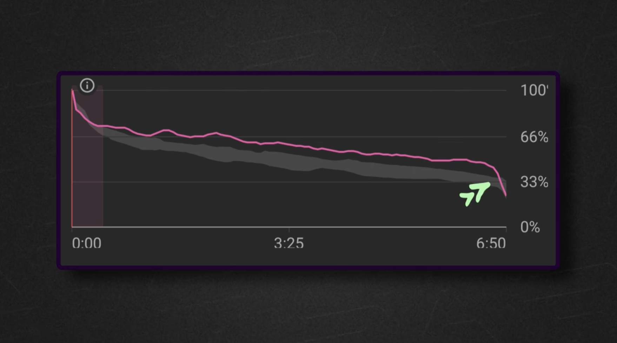
The second half fast decline
This can be caused by a few things:
1. You might have given a payoff too early and given the viewer the things they really cared about.
2. You might be labouring your point or not moving towards it fast enough so viewers have started to feel frustrated and skipped
3. You could have gone off on a tangent or
4. You might have overwhelmed your viewers
When you see this, ask yourself "why would 10% of people have left between point an and b?" The payoff too soon is often the culprit.
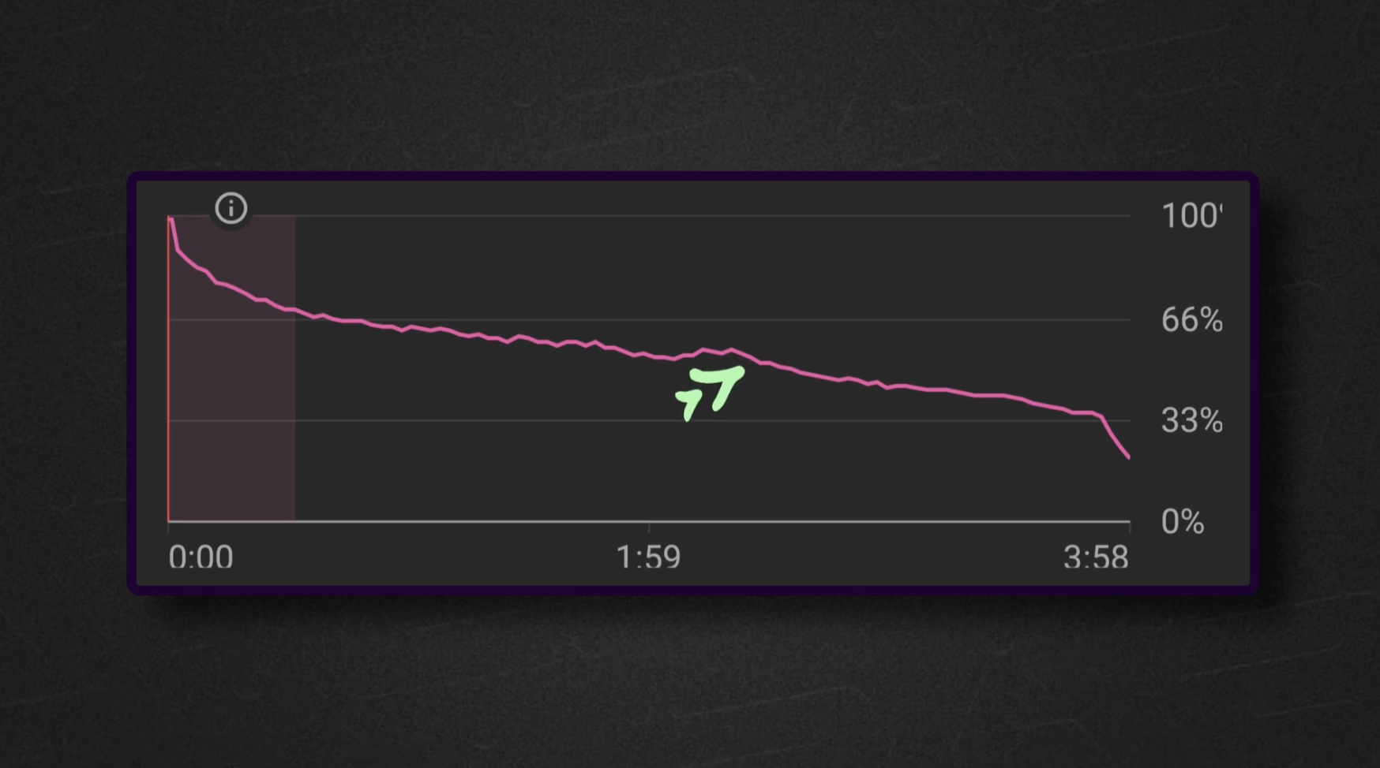
The lack of intrigue
This is the most common graph I see; it'll be a result of the setup not being enticing enough and then the way you deliver the information paying things off too soon.
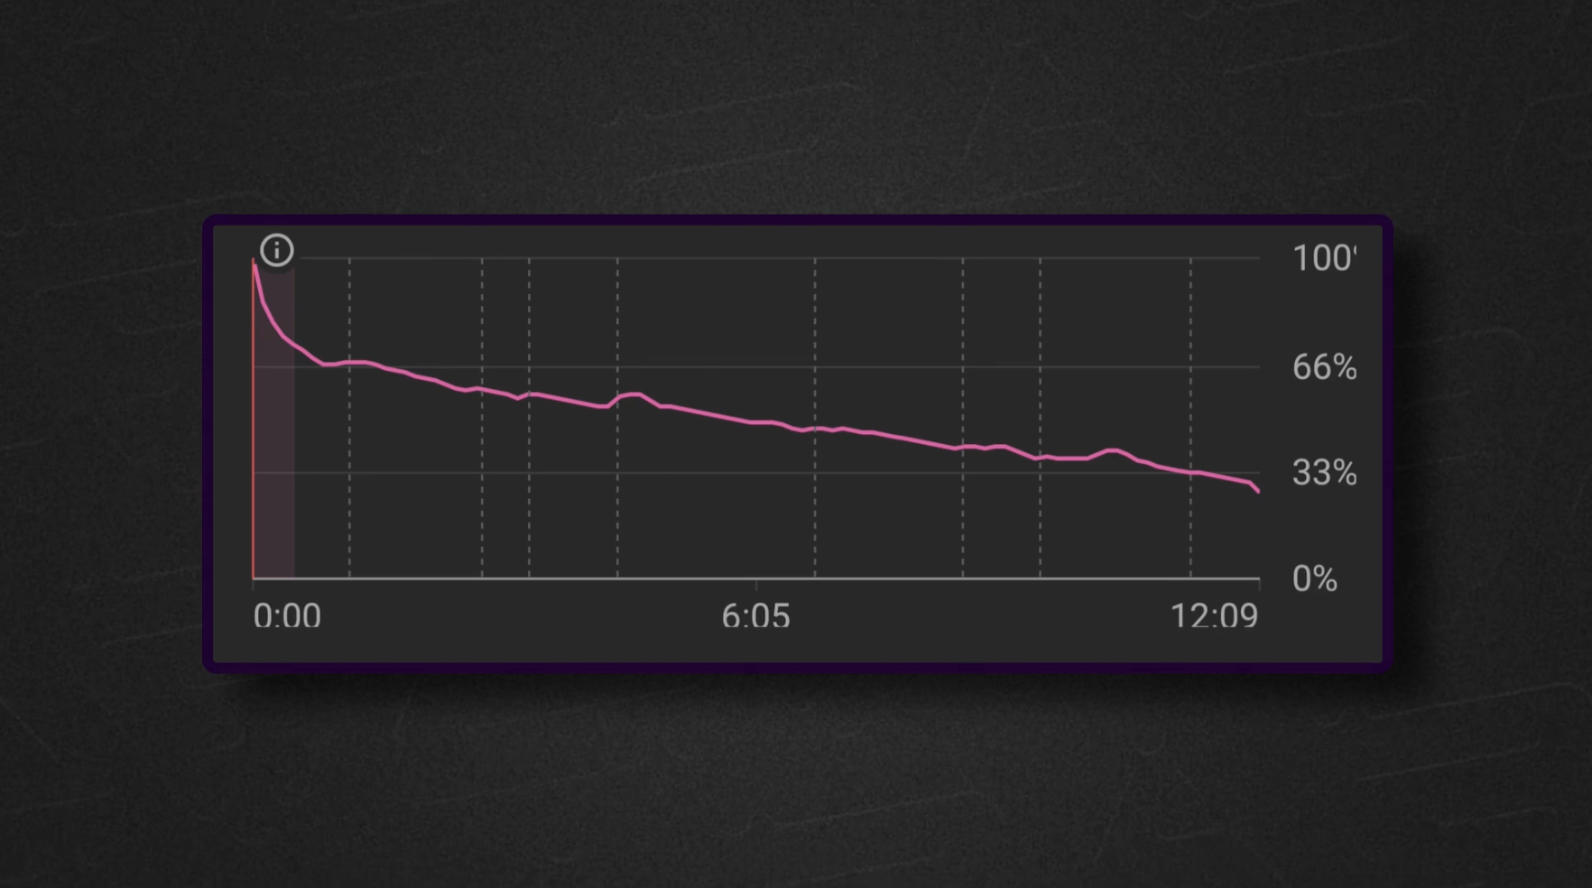
The Intro Drop
Getting your 30-second drop-off in the education sector above a 20% loss is pretty tough. If your intro labours the point, makes the video feel like clickbait, goes on too long, or doesn't set up things the viewers care about, it'll suffer.
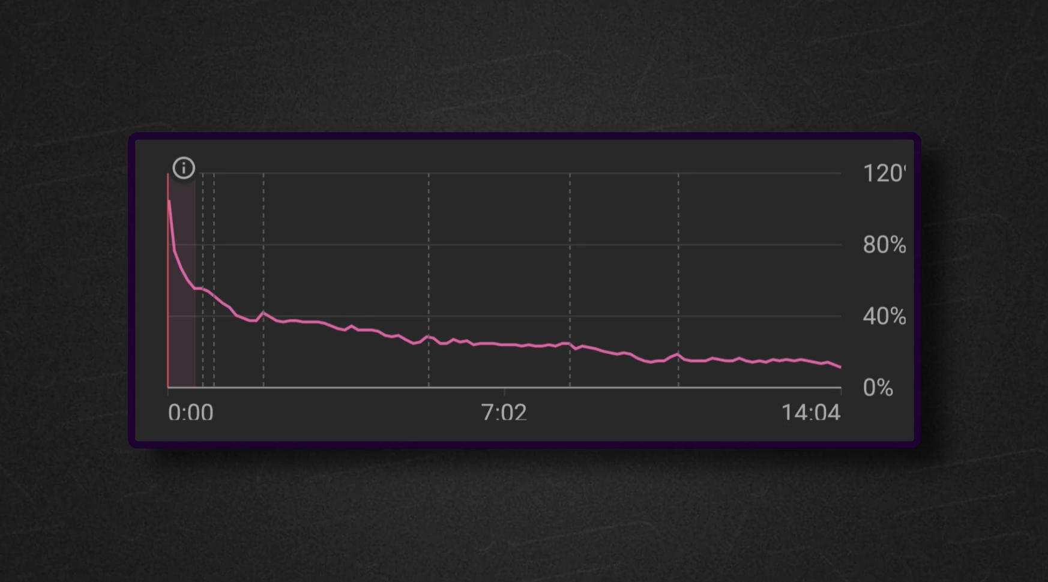
When to measure retention
24-48 Hours: The data will load after a day or two. When it loads, screenshot the graph and ask yourself what worked and what didn't for your initial viewers. (For those who are newer channels, you won't get much data here, so it's a luxury those with an existing audience have.)
Your initial viewers will mainly consist of 'core' and 'fans,' so this data will often be the best our graph ever looks.
2 Weeks Later: Screenshot the graph. This will now show you what the wider audience thought and the less 'hot' viewers.
Compare the graph to the 48-hour graph to see if there were any elements that put off colder viewers more than core viewers.
